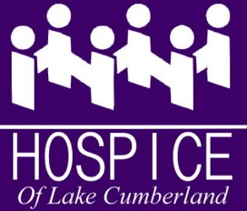

December 2022

Dear

Thanks to your generosity, HLC served about 1000 patients in 2022. We expanded our veteran services, continued to grow our bereavement offerings for children and adults, and were able to provide a number of patients with Bucket List requests.
Bucket List requests can run the gamut from simple to a bit complex, but these experiences mean the world to patients and their loved ones.

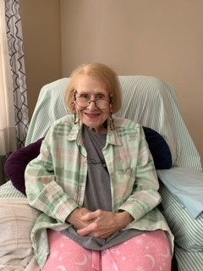
One patient wanted a makeover. When it was finished, she looked like a star!

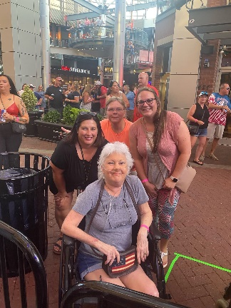
We helped a patient attend one more concert.

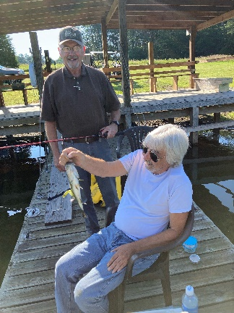

Another patient just wanted to go fishing.

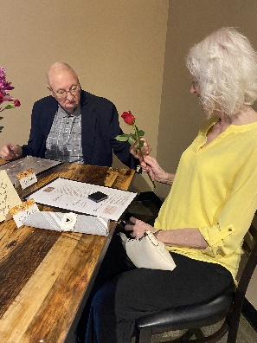

We assisted a patient who wanted to take his best girl out on one more date.

And, there was the patient who wanted to go camping with his family – just like he used to when his kids were young. They enjoyed a cabin on the lake and campsites!
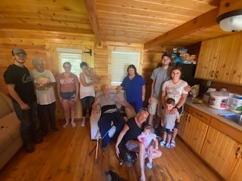

Hospice of Lake Cumberland provides end-of-life care in Pulaski, Russell, Wayne, Casey, McCreary, Clinton, and Cumberland Counties. We often say, “It’s About Living” because, in addition to providing our patients comfort care and symptom management, we also help them and their families make important memories. We walk with them every step of the way.
I’m reaching out to you because you have demonstrated your commitment to quality end-of-life care. Will you please help us meet our Year End Campaign goal to reach $25,000? With your support, we can continue to impact our community in a lasting way. Will you help us continue our work?
Please stand with our patients and their loved ones. So much is at stake.

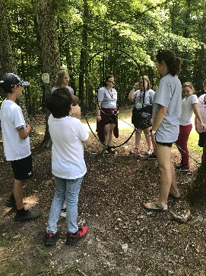
Wishing you a blessed holiday season,
Euretha Godby
Executive Director
Camp Promise
Children’s Bereavement Camp

